POS Tagging

1. With NLTK

Input –

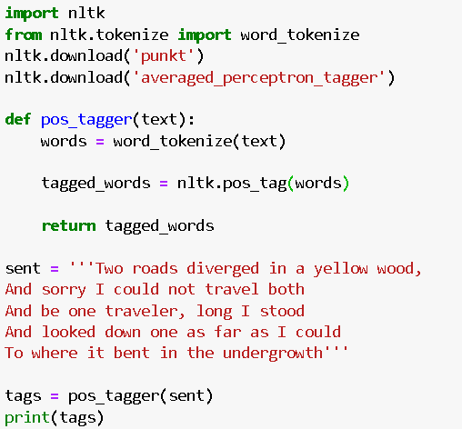

Output –

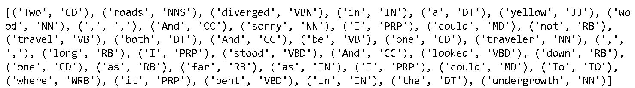

1. Without NLTK

Input –

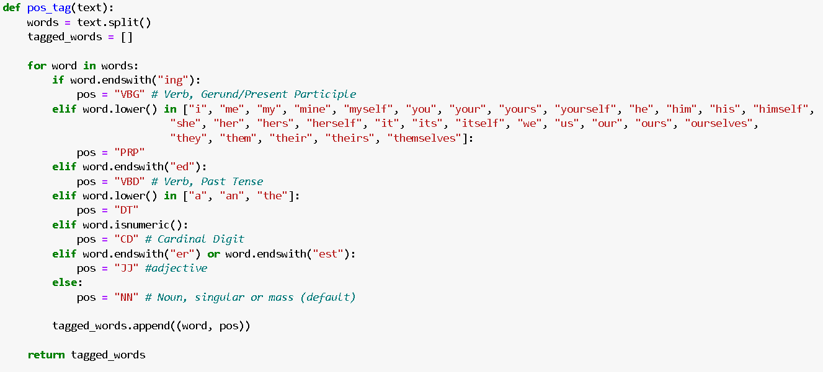

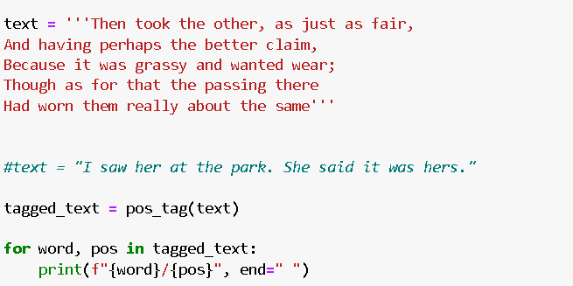

Output –



Repo Link

<https://github.com/Shreyaww/Sem7_NLP/blob/main/Experiment%206.ipynb>